# Exercise: CI/CD in GitHub Actions

Exercises for the "[DevOps for Developers](https://softuni.bg/modules/133/devops-for-developers-september-2024/1504)" module @ SoftUni

## CI Workflow – "Student Registry" App

### Step 1: Run the App Locally

We have the "Student Registry" Node.js **app** in the **resources**. Your task is to **create a CI workflow** in GitHub Actions to **start and test the app** on three different Node.js versions:

Let's first **start the app locally** in Visual Studio Code. To do this, you should **open the project**, open a **new terminal** from [Terminal] 🡪 [New Terminal] and **execute** the "npm install" and "npm start" **commands**:

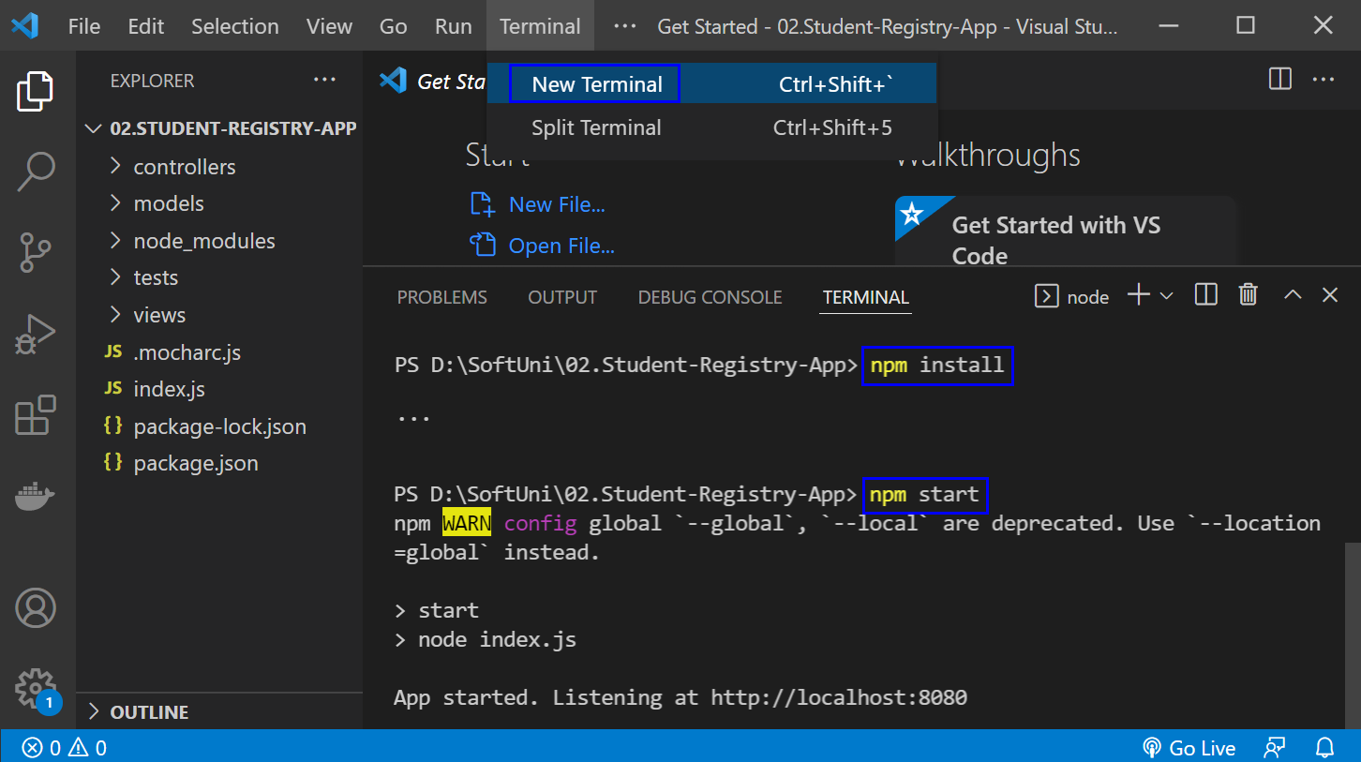

The "npm install" **command** **installs app dependencies** from the package.json **file** and "npm start" **starts the app**. You can **look at the app** on <http://localhost:8080>:

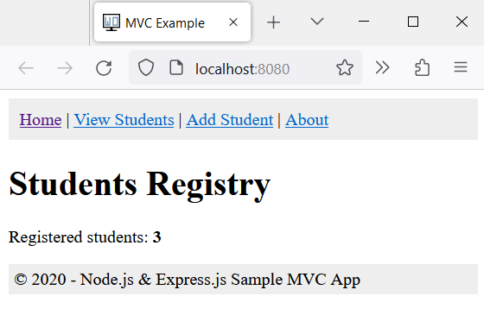

Then, you can **return to** VisualStudioCode, open a **new terminal** with [+] and **run** "npm test" to **run the app tests**. They should be **successful**:

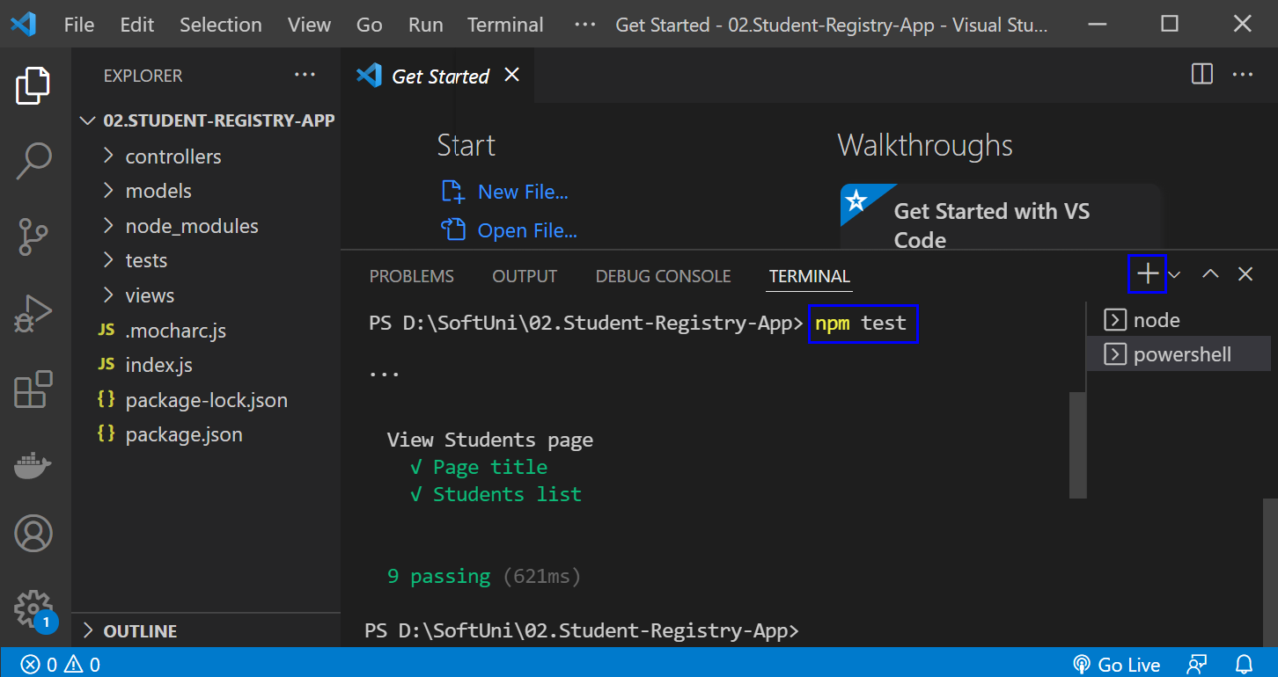

**NOTE**: if the **app was not started**, **tests would fail** because these are integration tests and are executed on the running app.

### Step 2: Create a GitHub Repo

Now you should **upload the app code to** GitHub.

It's a good practice to start using the console and not the interface of GitHub, in case you haven't started doing so yet.

If you don't have Git already installed on your machine, follow the provided installation instructions from the resources.

Try using the following commands in order to initialize a repository in your project directory, add the code to the repo, commit and push:









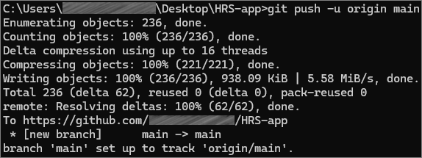

After running the commands, check you GitHub repo – the application code should be visible.

### Step 3: Create and Run Workflow

Now you should **upload the app code to** GitHub and **create a** GitHubActionsCI **workflow** to **start and test the app**. You can use the **following template**:

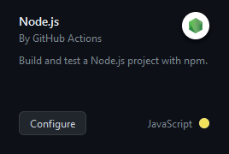

**Before you commit** the **generated** YAML **workflow file**, you should:

* **Change the YAML file name** to something more meaningful
* **Examine the workflow**, the **job** you have and its **steps**
* **Run the job** on the **last Node.js versions**: **18.x**
* **Change the workflow name**
* **Modify workflow job steps**: you should **use the three commands** which we used above to **start and test the app**, not the ones you have in the generated YAML file or **your workflow won't be successful**
* **Add names for each step** in your workflow job

Finally, **run the workflow job** and make sure that **it is successful**:

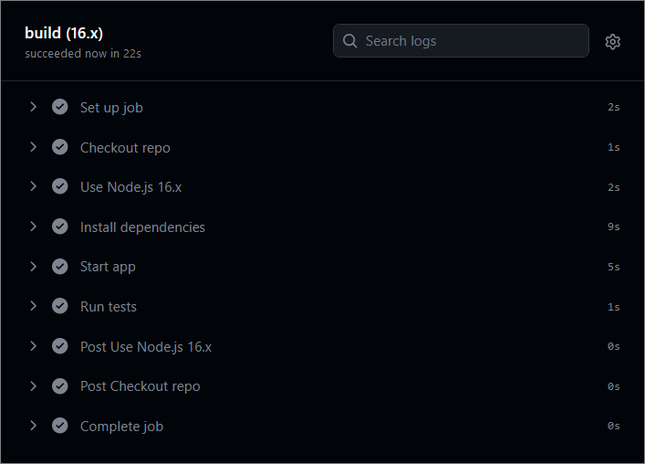

## CD Workflow – "Student Registry" App

Now, let's **create a** CD **workflow** for the "Student Registry" Node.js **app** to **deploy it to** Render.com.

We will continue working on the file that we created for the **CI** workflow.

To do this, you should **fulfill the following steps**:

* Create a free **Render.com account**
* **Generate an API Token:**
  + Navigate to the "**API Keys**" section in your **Render.com** Account settings;
  + Generate an API token by clicking on "**Create API Key**";
  + Give it a meaningful name (e.g., "**GitHub Actions Token**");
  + Click on "**Create Token**" to generate it.
* Add a new **Web Service:**
  + Connect your **GitHub** **account** to the service;
  + Connect your **GitHub** **repository** holding the application;
  + Give your **service a unique** and **meaningful** name;
* Add Render **Service ID as a GitHub Secret**:
  + Go to the **Settings menu** of your web service in Render.com and find the **Deploy Hook**;
  + **Copy the value that matches the pattern from the red square:**

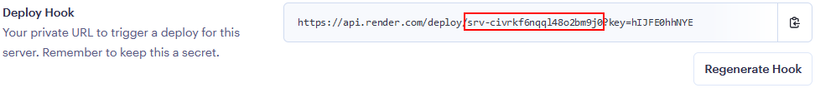

* + Go to your GitHub repository, click on "**Settings**," then select "**Secrets and variables**" from the left sidebar;
  + Click on "**Actions**" and then click on "**New repository secret**" and add a new secret with the following details:
    - Name: **SERVICE_ID**
    - Value: The service id that you copied from Render.com
  + Click "**Add secret**" to save it.
* **Add Render.com API Token as a GitHub Secret:**
  + Go to your GitHub repository, click on "**Settings**," then select "**Secrets and variables**" from the left sidebar;
  + Click on "**Actions**" and then click on "**New repository secret**" and add a new secret with the following details:
    - Name: **RENDER_TOKEN**
    - Value: The API token you generated on Render.com
  + Click "**Add secret**" to save it.
* **Create and define the CD workflow:**
  + Set the **job** to be **dependent** of the **test** job from the **CI workflow**
  + In the **YAML** file that we used for the CI workflow, use the **custom** GitHub action [**johnbeynon/render-deploy-action@v0.0.8**](https://github.com/marketplace/actions/render-deploy-action) to deploy the application to Render;
  + Use the Render service ID and API key, which are stored as secrets in the repository.

GitHub Actions will execute the CD workflow, which involves installing Node.js, installing dependencies, and deploying the app to **Render.com**. The workflow will log in to **Render.com** using the API token you provided as a secret and then deploy your app.

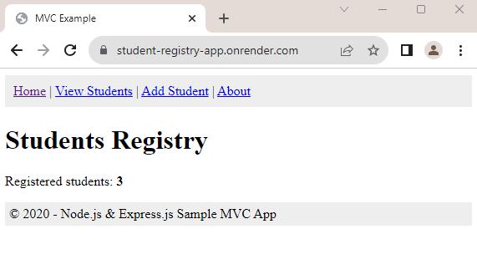

## * CI/CD Workflow – "Library Catalog" App

We have the "Library Catalog" **app** in the **resources**. Your task is to **create a CI/CD workflow** in GitHub Actions to **start, test** and **deploy** the app to Render.com following the steps from the previous tasks.



## "HouseRentingSystem" App – ASP.NET Core MVC app

### Step 1: Run the App Locally

We have the "HouseRentingSystem" ASP.NET Core MVC **app** in the **resources which has some unit and integration tests already**. Your task is to **create a CI workflow** with **GitHub Actions** to **start and test the app.**

It's a good practice to first **start the app locally** in Visual Studio, in order to be sure everything works properly and as expected.

Open **Visual Studio** and from there navigate to the **Tools** menu. Select **NuGet Package Manager** and select **Package** **Manager** **Console**:

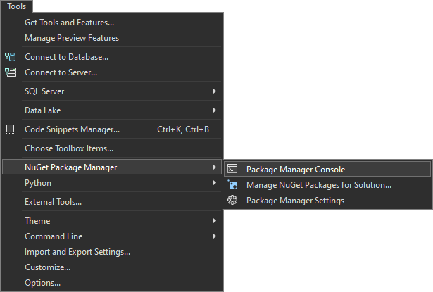

Let's first build the application by using the **dotnet build** command:

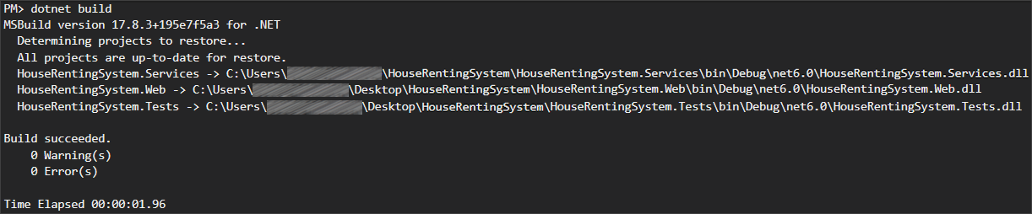

After you have **ensured** that the **build** was **successful**, you can **run** the **tests**, too, by using the **dotnet test** command:

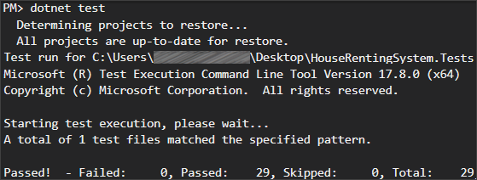

**NOTE:** Visual Studio has built-in test runners that allow you to run your tests directly from the IDE. This is the simplest way to execute tests if you're already working within Visual Studio. However, it's **better** to get used **using** the **console**.

**After** we have ensured that the **tests** **run** **successfully**, we can proceed with the next step.

### Step 2: Create a GitHub Repo

Now you should **upload the app code to** GitHub. Try using the CLI and the commands from the previous task to add the code to the repo and commit it.

### Step 3: Create and Run Workflow

Now you should **create a** GitHubActionsCI **workflow** to **start and test the app**.

You can use the **following template**:

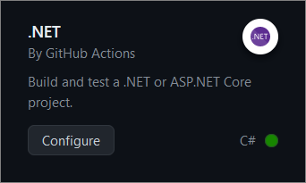

**Before you commit** the **generated** YAML **workflow file**, you should:

* **Change the YAML file name** to something more meaningful
* **Examine the workflow**, the **job** you have and its **steps**
* **Run the job** on .NET version **6.0**
* **Change the workflow name**
* **Modify workflow job steps**: you should **have jobs for** 
  + **Setting up .NET Core**
  + **Restoring dependencies**
  + **Building the app**
  + **Running the tests**
* **Add names for each step** in your workflow job

Finally, **run the workflow job** and make sure that **it is successful**:

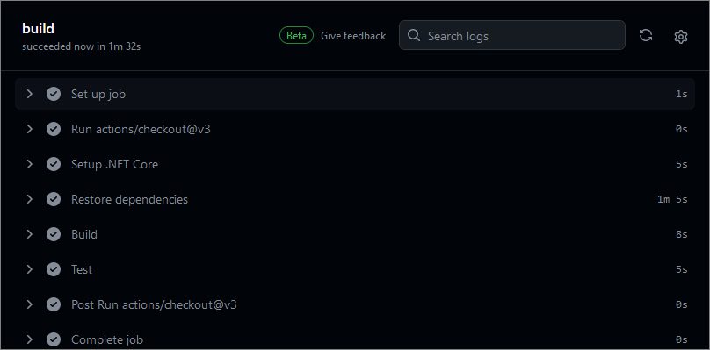

## Selenium IDE

### Step 1: Run the App Locally

We have the "SeleniumIde" solution in the **resources which has one test projects already**. Your task is to **create a CI workflow** with **GitHub Actions** to **run the tests automatically.**

It's a good practice to **build the solution locally** in Visual Studio, in order to be sure everything works properly and as expected.

Open **Visual Studio** and from there navigate to the **Tools** menu. Select **NuGet Package Manager** and select **Package** **Manager** **Console**:



Let's first build the application by using the following command:

|  |
| --- |
| **dotnet build** |

After you have **ensured** that the **build** was **successful**, you can **run** the **tests**, too, by using the command below or just by clicking on the **[Run All Tests in View]** button in the **Text Explorer**.

|  |
| --- |
| **dotnet test** |

**After** we have ensured that the **tests** **run** **successfully**, we can proceed with the next step.

### Step 2: Create a GitHub Repo

Now you should **upload the solution to** GitHub.

It's a good practice to start using the console and not the interface of GitHub, in case you haven't started doing so yet.

If you don't have Git already installed on your machine, follow the provided installation instructions from the resources.

Try using the following commands in order to initialize a repository in your project directory, add the code to the repo, commit and push:

|  |
| --- |
| **git init**  **git add .**  **git commit -m "Initial commit"**  **git remote add origin** [**https://github.com/{name-of-your-repository}**](https://github.com/%7bname-of-your-repository%7d)  **git push -u origin main** |

After running the commands, check you GitHub repo – the application code should be visible.

### Step 3: Add Changes to Test Files

Before creating the workflow file, we have to make some adjustments in the **.cs** files. This is needed due to the fact that the default GitHub runner does not have Chrome installed. We will take care of this in the workflow, but we also need the prepare the tests to run Chrome in a headless mode within the CI environment.

In order to do that, go to the **SetUp()** method of the project and modify it so it looks like below:

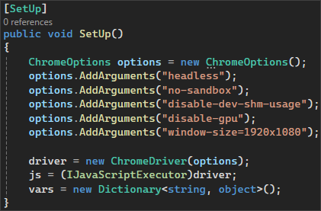

Don't forget to **commit** and **push** the changes from the file.

### Step 4: Create and Run Workflow

Now you should **create a** GitHubActionsCI **workflow** to **start and test the app**.

In the root directory of the repository, create a new folder **.github** and in it create another one, called **workflows**. Then, inside this new folder, create a **YAML** **file**, which will hold the workflow definition.

Now, let's define our workflow file.

We have to give it a meaningful name and specify the event which will trigger the workflow. In our case, this will be the push and pull request events on the **main** branch:

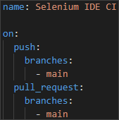

Then, we have to specify the **job** and the **environment**:



After that, we start defining the **steps.** You have to create several **steps** for the **job**:

* **Checkout code**
  + Give the step a meaningful name
  + Checkout the repository code



* **Set up .NET Core**
  + Give the step a meaningful name
  + Use the appropriate action to set up the .NET Core SDK
    - Specify the .NET Core version

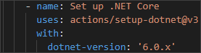

* **Install Chrome**
  + Give the step a meaningful name
  + Executes commands to update the package list and install Google Chrome

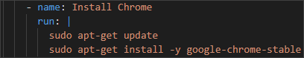

* **Install dependencies**
  + Give the step a meaningful name
  + Run the appropriate command to restore the dependencies specified in the solution file



* **Build the solution**
  + Give the step a meaningful name
  + Run the appropriate command to build the solution without restoring the dependencies again



* **Run the test project** 
  + Give the step a meaningful name
  + Sets the environment variable **CHROMEWEBDRIVER** to the path of the Chrome executable
  + Run the tests in the project with normal verbosity

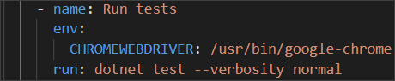

Now, commit the changes to the main branch of the repository.

Finally, **the workflow job should run after the commit.** Make sure that it is **successful**:

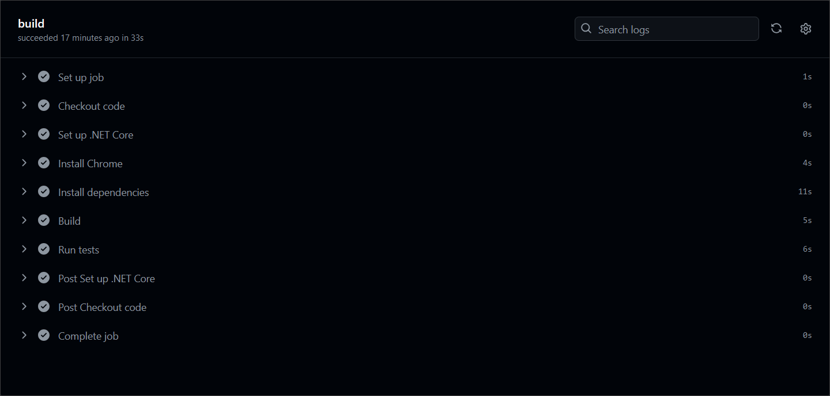

## Selenium Web Driver

Our second task will be to create a CI for using Selenium to automate several test projects, combined in one solution.

### Step 1: Run the App Locally

We have the "SeleniumBasicExercise" solution in the **resources which has four test projects already**. Your task is to **create a CI workflow** with **GitHub Actions** to **run the tests automatically.**

It's a good practice to **build the solution locally** in Visual Studio, in order to be sure everything works properly and as expected.

Open **Visual Studio** and from there navigate to the **Tools** menu. Select **NuGet Package Manager** and select **Package** **Manager** **Console**:



Let's first build the application by using the **dotnet build** command:

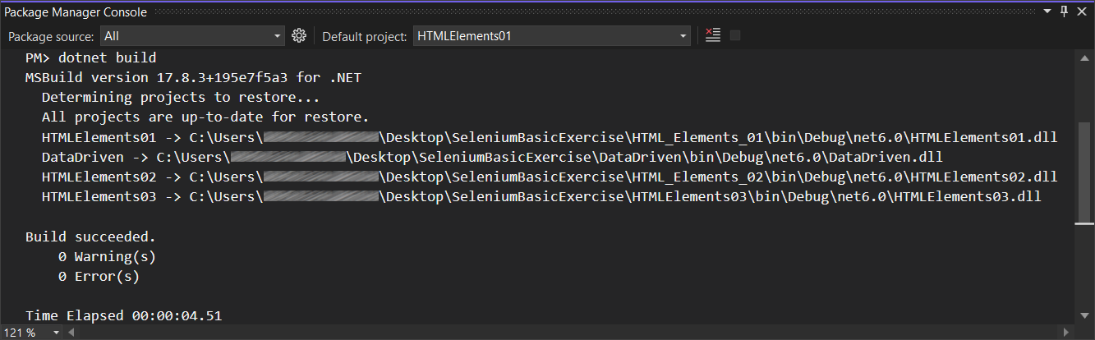

After you have **ensured** that the **build** was **successful**, you can **run** the **tests**, too, by using the **dotnet test** command or just by clicking on the **[Run All Tests in View]** button in the **Text Explorer**.

**After** we have ensured that the **tests** **run** **successfully**, we can proceed with the next step.

### Step 2: Create a GitHub Repo

Now you should **upload the solution to** GitHub.

It's a good practice to start using the console and not the interface of GitHub, in case you haven't started doing so yet.

If you don't have Git already installed on your machine, follow the provided installation instructions from the resources.

Try using the following commands in order to initialize a repository in your project directory, add the code to the repo, commit and push:









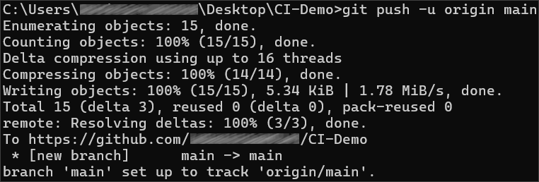

After running the commands, check you GitHub repo – the application code should be visible.

### Step 3: Add Changes to Test Files

Before creating the workflow file, we have to make some adjustments in the **.cs** files. This is needed due to the fact that the default GitHub runner does not have Chrome installed. We will take care of this in the workflow, but we also need the prepare the tests to run Chrome in a headless mode within the CI environment.

In order to do that, go to the **SetUp()** method of each project and add the following code:  
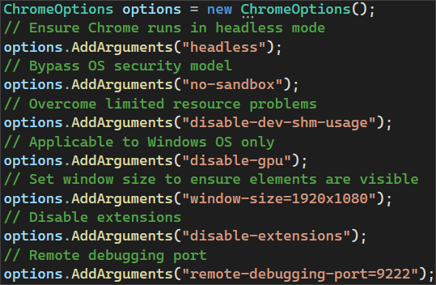

Then, we need to pass the **ChromeOptions** to the **ChromeDriver** constructor:



Don't forget to **commit** and **push** the changes to each one of the files.

### Step 4: Create and Run Workflow

Now you should **create a** GitHubActionsCI **workflow** to **start and test the app**.

In the root directory of the repository, create a new folder **.github** and in it create another one, called **workflows**. Then, inside this new folder, create a **YAML** **file**, which will hold the workflow definition.

Now, let's define our workflow file.

We have to give it a meaningful name and specify the event which will trigger the workflow. In our case, this will be the push and pull request events on the **main** branch:

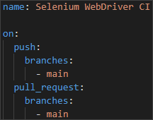

Then, we have to specify the **job** and the **environment**:



After that, we start defining the **steps.** You have to create several **steps** for the **job**:

* **Checkout code**
  + Give the step a meaningful name
  + Checkout the repository code



* **Set up .NET Core**
  + Give the step a meaningful name
  + Use the appropriate action to set up the .NET Core SDK
    - Specify the .NET Core version



* **Install Chrome**
  + Give the step a meaningful name
  + Executes commands to update the package list and install Google Chrome



* **Install dependencies**
  + Give the step a meaningful name
  + Run the appropriate command to restore the dependencies specified in the solution file



* **Build the solution**
  + Give the step a meaningful name
  + Run the appropriate command to build the solution without restoring the dependencies again



* **Run each test project separately**
  + Give each step appropriate and meaningful name, describing which test project is being executed
  + Sets the environment variable **CHROMEWEBDRIVER** to the path of the Chrome executable
  + Run the tests in each project with normal verbosity

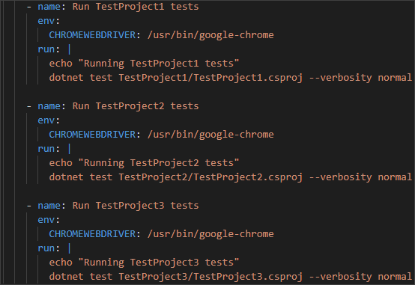

Now, commit the changes to the main branch of the repository.

Finally, **the workflow job should run after the commit.** Make sure that it is **successful**:

